
Data sheet (lab 2)

Course: CSE209 Electrical Circuits
Experimental name: Series-Parallel DC Circuit and verification of Kirchhoff’s laws

Submitted By:
D.M. Rafiun -Bin- Masud
ID: 2019-3-60-137
Department of CSE

Submitted to:
Rashedul Amin Tuhin
Senior Lecturer,
Department of Computer Science and Engineering

Experimental name: Series-Parallel DC Circuit and verification of Kirchhoff’s laws

Experiment Datasheet:

Measured Value | Simulated Value | Calculated
E | 2.9V | 3V
V1 | 2.2V | 2.2V
V2 | 0.705V | 0.7V
V3 | 0.7V | 0.7V
I1 | 22.73mA | 0.022A
I2 | 15.46mA | 0.015A
I3 | 7.268mA | 0.007A

Diagram: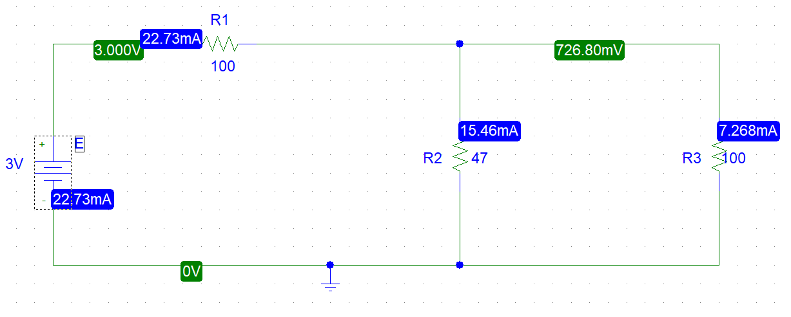
Answer to prelab questions: